Software projects: Fitness app Exercises

These are the exercises i have decided are the best to include in the app. I have decided on these exercises from personal experience as well as research into the most effective exercises for the particular muscle groups.

The app will include the following muscle groups:

* Legs (glutes,quads,calves)
* Arms(Biceps, Triceps, Forearms)
* Shoulders
* Back(Upper back, Lower back)

The exercises will be separated by skill level as there will be a easy, Intermediate and hard skill levels.

**Leg exercises**

Lunges

Stand with your feet hip-width apart, holding dumbbells at your sides. Take one giant step forward with your right foot, and upon your foot's landing, bend your right knee at a 90° angle, making sure your knee stays behind your toes, while simultaneously bending your left leg toward the floor.

Push yourself back up to your starting position, and repeat the movement. Try to do 3-4 sets of 8-12 reps on each side; if you see that you can do more, without feeling a burn, increase the weight of the dumbbells you are holding, until 12 reps is a challenge.

**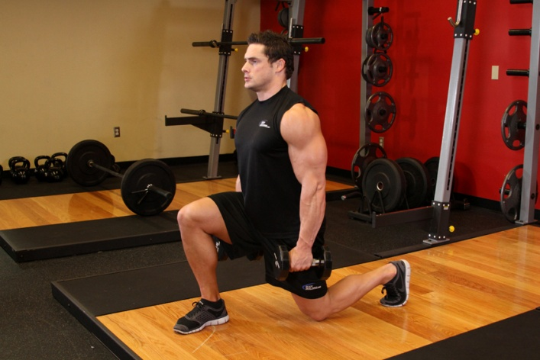**

**Muscles worked:** glutes, quads, calves

https://www.youtube.com/watch?v=D7KaRcUTQeE

Calf raises

Standing with your heels hanging off the edge of a step, holding dumbells by your sides, push yourself up onto your toes, and slowly come down. Again, aim for 3-4 sets of 8-12 reps, increasing the weight if you feel that it is not challenging enough.

### C:\Users\Andria\Desktop\219_2.jpg

**Muscles worked:**  calves

Easy: https://www.youtube.com/watch?v=-M4-G8p8fmc

Hard : https://www.youtube.com/watch?v=3UWi44yN-wM

### Leg extensions

Sit on the leg extension machine, with your knees bent and the foot pad on your shins. Straighten your legs, until they are parallel to the floor. Then bring them back down. You guessed it: 3-4 sets, 8-12 reps.

**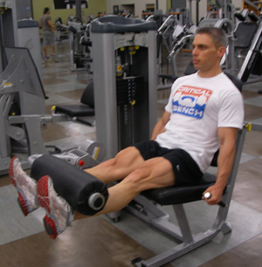**

**Muscles worked:** quads

https://www.youtube.com/watch?v=OjRjyvnLTgU

**Arms**

### [ZOTTMAN CURL](javascript:pop('zottman-curl'))

### Are you having trouble deciding which biceps exercise to do? Choose the Zottman. In this movement you have a palms-up (supinated) grip on the way up and a palms-down grip (pronated) as you lower the weight. All of your elbow flexors get hit in one swoop. The brachioradialis and the brachialis take heat on the negative, and during the curling motion itself, the biceps brachii bears the load.My recommendation would be to rotate the wrist *as you come up* instead of just doing it at the bottom before the rep starts. Some of your elbow flexors act as supinators as well, and rotating the wrist during the curl instead of at the bottom will load up that function.

### zottman curl

### https://www.youtube.com/watch?v=F\_MzS5HCy3k

### https://www.youtube.com/watch?v=Aw3q\_QQdDVk

### [OVERHEAD CABLE CURL](javascript:pop('overhead-cable-curl'))

### This movement is a great way to practice your front double biceps pose as you train. With our arms in this position, brachialis recruitment is maximized. Thehigher your elbow, the more isolated the brachialis is from the biceps brachii.A good variation is to do one arm at a time, getting the arm straight up (against the head), curling behind your head.

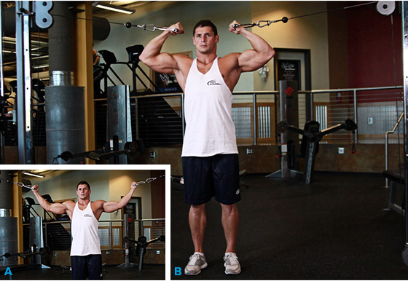

https://www.youtube.com/watch?v=5\_n3gVeGEqc

Hard: https://www.youtube.com/watch?v=d4YaCgGG-so

### [WIDE-GRIP STANDING BARBELL CURL](javascript:pop('wide-grip-standing-barbell-curl'))

### Taking a wider-than-normal grip will cause you to externally rotate at the shoulder, so your humerus changes its position. This prompts more involvement from the short head of the biceps. For this and all barbell curls, avoid cheating reps by leaning back. If you want to overload the top, use bands, chains, or a partner for forced reps.

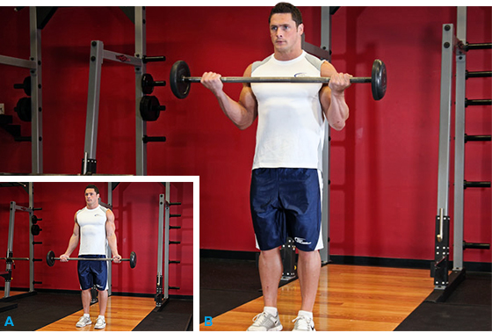

### https://www.youtube.com/watch?v=x0s-hL3CuKg

### Arms(triceps

Lying Barbell Triceps Extensions

These fundamental favourites isolate intense stress on the triceps, particularly the medial and outer heads. Taking a narrow overgrip in the middle of a moderately weighted barbell, lie on your back on an exe

rcise bench. Keep your feet on the sides of the bench to provide balance.

|  |  |
| --- | --- |
| [http://www.bodybuilding.com/fun/2002/lyingtriceppress1s.jpg](http://www.bodybuilding.com/fun/2002/lyingtriceppress1.jpg) | [http://www.bodybuilding.com/fun/2002/lyingtriceppress2s.jpg](http://www.bodybuilding.com/fun/2002/lyingtriceppress2.jpg) |

### https://www.youtube.com/watch?v=a2TkTaXagRQ

**Standing Barbell Triceps Extensions**

This is a fundamental triceps exercise, stressing the inner and medial heads of the triceps muscle complex. Take a narrow overgrip in the middle of a moderately-weighted barbell. With feet about shoulder width apart, stand erect, and extend your arms straight up from your shoulders.

|  |  |
| --- | --- |
| [http://www.bodybuilding.com/fun/2002/standingovertricext1s.jpg](http://www.bodybuilding.com/fun/2002/standingovertricext1.jpg) | [http://www.bodybuilding.com/fun/2002/standingovertricext2s.jpg](http://www.bodybuilding.com/fun/2002/standingovertricext2.jpg) |

**https://www.youtube.com/watch?v=qkZBtEHUjfw**

**One-Dumbbell Triceps Extensions**

This movement stresses the entire triceps muscle complex, particularly the inner and medial heads. Take the dumbbell and grip it so that your palms are facing the inner-top plate and the dumbbell is hanging straight down (perpendicular to the [gym](http://www.bodybuilding.com/fun/bbinfo.php?page=ChoosingAGym) floor). To keep the weight from slipping, encircle your thumbs around the dumbbell handle.

|  |  |
| --- | --- |
| [http://www.bodybuilding.com/fun/2002/standingtricepex1s.jpg](http://www.bodybuilding.com/fun/2002/standingtricepex1.jpg) | [http://www.bodybuilding.com/fun/2002/standingtricepex2s.jpg](http://www.bodybuilding.com/fun/2002/standingtricepex2.jpg) |

https://www.youtube.com/watch?v=\_gsUck-7M74

**Back**

Deadlifts



Sumo deadlifts, conventional deadlifts, beyond the range (from a deficit), rack pulls - it doesn’t matter, just do them. The back not only works antagonistically to stabilize the torso (and spine) it works to lock out the weight to finish the movement. Deadlifts, by definition, are an exercise where you can move big weight.

https://www.youtube.com/watch?v=RyJbvWAh6ec

Pull ups/ chin ups

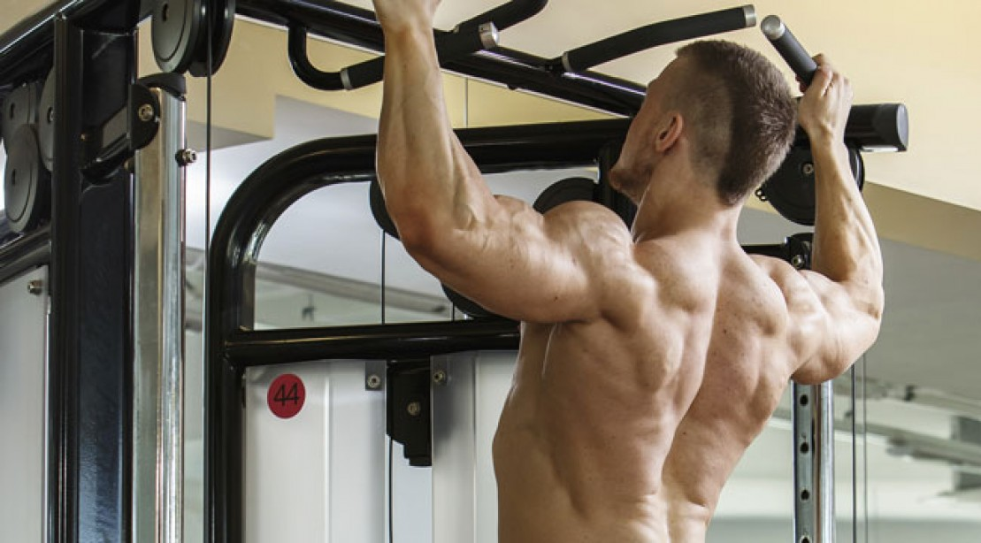

When you see someone walking around the gym with a [big back](http://www.muscleandfitness.com/training/back/big-back-workout), you can guarantee they can jump up and kill 15-20 [pull-ups](http://www.muscleandfitness.com/training/back/9-ways-amp-pull) without even breaking a sweat. See the connection? Pull-ups and chin-ups are two of the best mass builders for the back. Targeting the lats, shoulders, biceps and grip, these exercises have so many different varieties, you’ll never get bored.

**Modifications:**

* Change the grip; wide, narrow, alternated
* Change the grip again; towels, thick ropes, two fingers, three fingers, gloves
* Overloaded; dip belt, med ball, sandbag, dumbbell, kettlebell
* Change the movement; side-to-side, slow negatives, holds, explosive

https://www.youtube.com/watch?v=-ApeELnYdBs